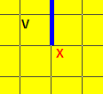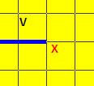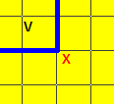 Can the V move diagonally to kill the X in these situations?

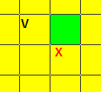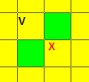

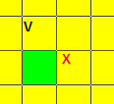

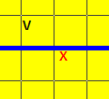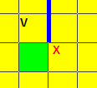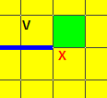

What’s the story with V’s going diagonally into arrows? *Yes*

Can a V move diagonally into a box of 4? *No*

Can a V move diagonally if it is not killing? *No*

What happens if an @ that is in the same tile as another character swaps places with a Pi? *Can’t happen*

If a T goes through an anger, can it still detonate with another T? *No*

Can $ use W as a target for AEO stun? *No*

What is the limit to how far away $ can cast AOE stun? *5*

Can U stealth through Pi? *no*

Can you have neutral Big W? *no*

How do you control a Big W?

How do you control a small W? (Small W can heal or cure stun.) *Has to cure stun b4 can heal*

With Big W, how do you choose whether it takes from or gives lives to its own G? *Your choice.*

Can the W heal the G in these situations?

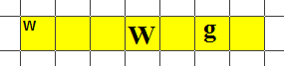

Pre

Press CTRL then click on char. Maybe a box comes up.

What happens if you turn Question Mark into Big W or Pi when there are other characters in the same tile? (Big W and Pi cannot get into a tile with own characters.) *You can’t. Pi and W don’t show up in choosing box.*

Can Purple Question Mark turn back into a Question Mark after turning into another character? *Yes*

If a purple G turns into another character then back to a G, does it regain its hits? *Yes*

Can a purple character use a move to turn into itself? *No*

Can a normal Question Mark use a move to turn into a Question Mark? *No*

If you turn a purple Pi into something else, does the concrete remain? *No*

What happens if a purple U stealth’s into steal and then turns into a Pi? *It can’t.*